UN report into Kabuga’s death: where does it leave genocide survivors?
Rwandajustice4genocide.org.uk 17 July 2026
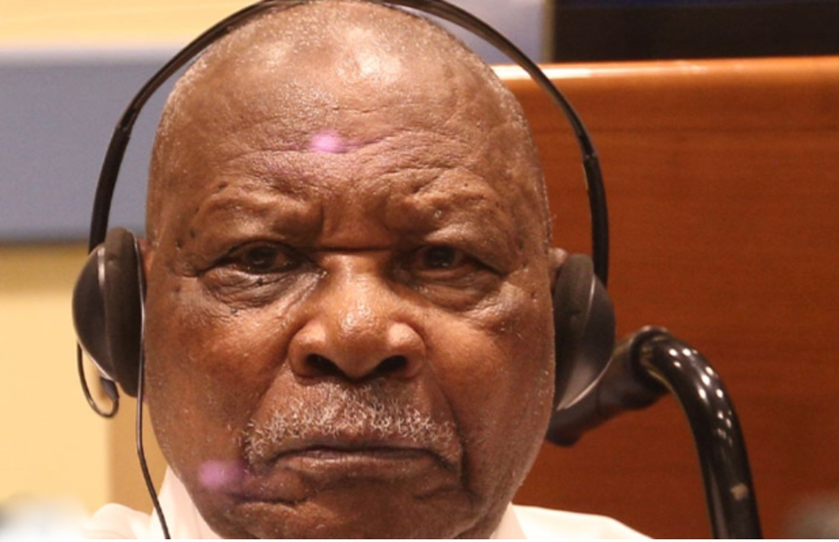
A 22-page UN judicial report into the death of the Felicien Kabuga, published on 6 July, reveals the cause of his death and fascinating details of the highly complex and expensive 24/7 medical treatment the genocidaire and longtime fugitive from justice received during his six-year stay in UN prison and hospital facilities in The Hague.
Kabuga, 91, the former President of Hutu hate radio RTLM and leading enabler of the Interahamwe, was found to have died from a suspected heart attack at around midday on 16 May. His family refused to give authorities permission for an autopsy on his body so the cause of death could not be definitively established. On the day of his death Kabuga was in his cell – number seven on the ground floor of the newly commissioned prison hospital centre that cared for elderly prisoners (JCvSZ). It provided 24/7 care and was just a short walking distanced from the UN detention centre (UNDU) at Haaglanden, a suburb of The Hague. Kabuga had breakfasted at 8.30 and later called his daughter for a seven minute phone conversation. At midday, prison staff had brought his lunch (rice, carrots, meat, tea and yoghurt), and he had responded by giving them a ‘fist pump’ greeting as they left. Around 50 minutes later it was noted he seemed asleep in his wheelchair, with the meal only half eaten. A doctor who entered the cell pronounced Kabuga dead at 12.51.
Kabuga had arrived in the UN Hague detention facilities in late 2020 and had been immediately placed in quarantine as prosecutors feared the on-going Covid pandemic would deprive them of the long-awaited chance to put him on trial. A fugitive from justice for 26 years, Kabuga had finally been arrested living in a one-bedroom flat in central Paris on 16 May 2020. The French authorities were only too willing to get him transferred to UN custody as soon as possible. On arrival in The Hague, Kabuga was given a hearing aid and glasses, treatment for type 2 diabetes, high blood pressure and osteoporosis. In February 2021 he suffered a fall and spent three months in a civilian hospital recovering from a broken femur (thigh bone). In July the same year, as prosecutors were attempting to get his trial for genocide underway, Kabuga returned to hospital with kidney issues and having suffered a mini stroke. His trial finally began in late September 2022, with Kabuga attending some days in person and others by video conference from the detention unit.
Kabuga’s healthcare at this point included special provisions and nursing care to ‘facilitate his daily activities’ which involved a dietician and physiotherapist as well as ‘exercising on a home trainer and a rollator.’ He was one of the first to receive the Covid vaccine when it became available. An MRI scan on his brain in June 2023 showed evidence of a loss of brain tissue and three medical experts deemed he was unfit to face justice. On 7 August 2023 the UN appeal court ordered an immediate stay of proceedings in his trial. Given no country (other than Rwanda) would allow Kabuga on its territory due to fears of immense reputational damage and the high cost of his medical care, it was left to the UN and its taxpayers to pick up the bill for looking after his 24 hour a day care and his increasingly complex and expensive mental and physical needs. His life at the UN specialised medical centre included personal therapy ‘shown to have a positive and calming effect on some patients with dementia. Sensory activation was introduced with illustrations and Kinyarwanda text to improve communication.’ This therapy was due to Kabuga’s ‘increasingly challenging’ moods and ‘strong reactions’ against staff who had to care for him. He had a special reclining wheelchair for comfort and to get about in, though in his last year Kabuga had lost his mental capacity to even know what day or year it was.
Kabuga’s death on 16 May was not unexpected, even if for the last six months of his life his health had been stabilised by the highly impressive care regime put in place by the UN medical staff. On 28 May his body was transferred to Belgium and he was buried on 2 June in Waterloo, Brussels where his wife Josephine was buried. After the public outcry over burial of Protais Zigiranyirazo (‘Z’) in Rouen last August, this time the whole affair was kept secret and enacted as quickly as possible.
This UN report on Kabuga’s death, by Dutch judge Alfons Orie, makes clear that for the five and a half years the UN ‘looked after’ Kabuga, it gave him every medical assistance and expert care. Had he remained in hiding at the flat in central Paris where he lived for several years until his arrest in 2020, it is probable Kabuga would have died far sooner given the lack of medical assistance his family were able to provide. However, this report will leave survivors of his crimes, and future generations who are impacted by them, feeling uneasy. It is one of the contradictions of international justice that the comprehensive support and care given to the criminals it ‘looks after’ can seem in stark contrast to that received by their ‘forgotten’ victims and survivors living with the immense trauma of loss, of rape, of ill health, of the infirmities of old age. They have no access to the UN-funded physiotherapists, dieticians, state-of-the-art MRI scans, expert dementia care or super-fast access to life-saving vaccines. Indeed, the ‘duty of care’ to genocide perpetrators continues even after they have left UN custody. In Niger, released or acquitted individuals live in a UN-paid-for house and have benefitted from the UN Mechanism handing each of them annually a cheque for $10,000 ‘living expenses’ along with paying for their medical care. Such generosity to men like Z and Anatole Nsengiyumva, the ‘butcher of Gisenyi’, contrasts with the acute lack of any compensation or ‘duty of care’ shown by the UN to the survivors of genocide and war crimes.
The details in this comprehensive UN report about Kabuga sheds new light on how those in its custody for the most serious offences are treated, especially when in need of special care when suffering from physical and mental illness. Fortunately, such individuals have loud voices working for them to make sure all is well thanks to their very diligent and high-profile legal teams and detailed protocols and mandates concerning the ‘duty of care’ the UN must provide to those in its custody. The stark reality for ‘voiceless’ genocide survivors and victims is they have no powerful voices to represent them or call for assistance, and no UN protocols detailing a ‘duty of care’ to them. For them, when growing old and becoming sick, the world is a very different place.
The full UN report can be viewed here: https://rwandajustice4genocide.org.uk/wp-content/uploads/FK-UN-report-on-death-July26.pdf

Rwandajustice4genocicde.org.uk July 2026

