Felicien Kabuga: A Life of Greed, Genocide and Impunity
Rwandajustice4genocide.org.uk May 2026
Felicien Kabuga, once one of the most wanted fugitives from justice with a $5 million bounty on his head, died in UN medical facilities in The Hague on 16 May 2026. The death of the once powerful businessman will not be mourned in his home country of Rwanda where his bloody legacy still resonates in the lives of victims and survivors of the 1994 genocide against the Tutsi.
Kabuga was born on 19 July 1935 in the north east prefecture of Byumba, (Muniga secteur, Mukarange commune). Rwanda was then under Belgian colonial rule. The lack of any real basic infrastructure - roads, airports, banks, water, media, hospitals, secondary schools/universities – meant most of the 95% of inhabitants relied on self-sufficient farming to feed themselves and their families – including Kabuga’s parents, Pierre Gasimba and Tibamwenda, (born Mugina).

Not much is known of Kabuga’s schooling, but it is likely he attended primary school and given the difficulty in attending secondary school – such establishments were few and far between and had a very basic level – his entrepreneurial skill in making a swift profit from selling cigarettes and used clothes in the local markets and villages soon took over his life. He moved to the capital Kigali and began to expand his business dealing. Within a few years he had founded companies such as ETS Kabuga – that dealt in petroleum products, as well as expanding his business portfolio into running tea plantations, flour milling, property letting and real estate, as well as a highly productive transport and carrier business.
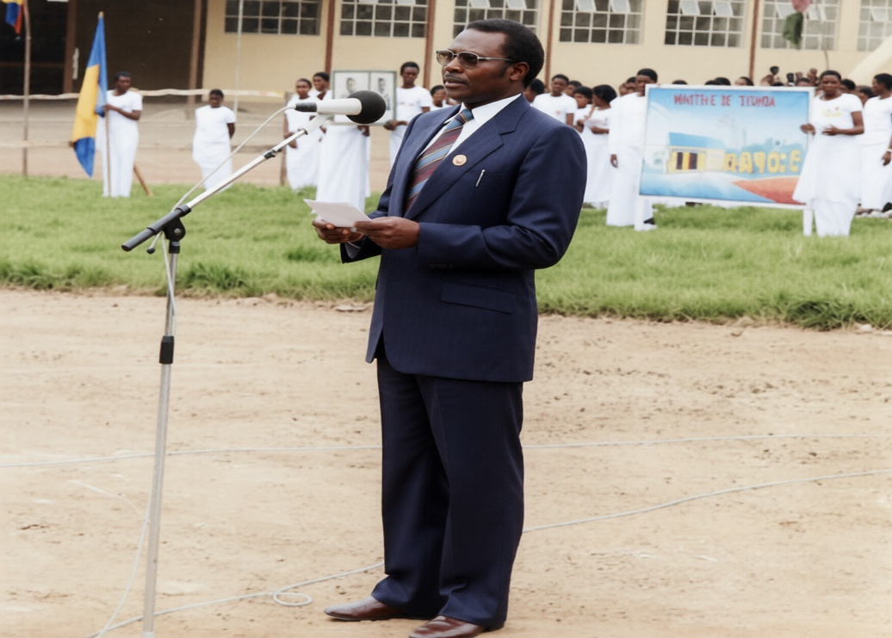
Kabuga speaking at the opening of his flour mill in Byumba, 10 October 1987 – during the ‘golden years’ of Akazu when the businessman expanded his real estate, tea, transport and flour empire to become Rwanda’s first ‘billionaire.’
He married Joséphine Mukazitoni, who was 6 years younger than him (born in January 1942), and was also from Byumba. In the coming years they had 11 children: 3 sons - Gilbert Habumukiza, Donatien Nsmyumuremye, Innocent Twagirumukiza) and 8 daughters - Félicité Mukademali, Françoise Mukanziza, Winnie Musabayezu, Pauline Musanabera, Claudine Marie Twagirihirwe (Cherry), Bernadette Uwamariya, Angélique Uwihirwe, Séraphine Uwimana.
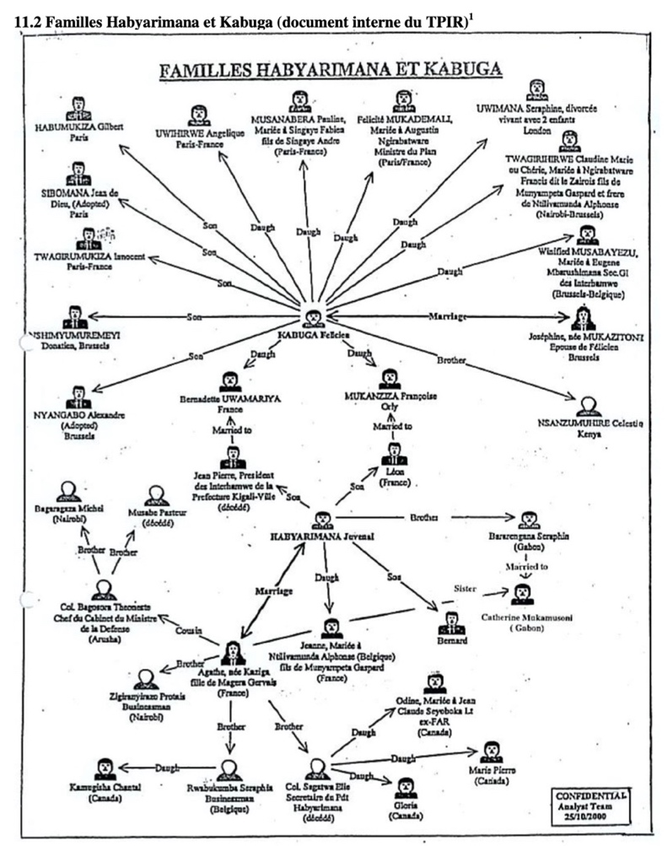
ICTR research document showing the complex familial ties between Felicien Kabuga and President Juvenal Habyarimana. Source: UNICTR

After his coup in 1973, which eliminated the former president Gregoire Kayibanda and hundreds of his senior military, political and administrative aids, President Juvenal Habyarimana installed his own one-party (MRND) state on Rwanda. ‘Preferment’ in any realm of life – education, health, administration, business, the military and within the churches was possible only with the ‘blessing’ of the ‘Akazu’ or close family around Agathe Kanziga, the presidents’ wife. For Kabuga, future prosperity in such a state was totally dependent on unifying himself personally, politically and financially with Akazu.
Two of Kabuga’s 11 children married into President Habyarimana’s family. In 1993 his daughter Bernadette Uwamariya was ‘persuaded’ to marry Habyarimana’s playboy son Jean-Pierre, a man given to a flamboyant lifestyle of partying, drink, pretty girls and dubious business practices. One year after the genocide in 1995, when hopes were still high that the now exiled Hutu genocidal regime would launch a successful invasion of Rwanda, Kabuga’s daughter Françoise Mukanziza married Habyarimana’s son Leon in Nairobi on 17 August 1995, where the two families were now living in opulent exile. Added to these ties, another daughter of Habyarimana, Jeanne, married Alphonse Ntilivamunda – the brother of Francois Ngirabatware who was married to Kabuga’s daughter Claudine (Cherry).
Politically, Kabuga allied himself as a strong supporter of the President’s political party, MRND. With its regionalist and ethnicist agenda, MRND found itself from 1991 having to battle with a new political landscape of multiparty politics and an on-going civil war. Kabuga became a vital ‘cog’ in supporting Habyarimana politically and financially as the media and youth were radicalised and weaponised in order to retain power. Kabuga regularly attended large MRND public rallies alongside the president and other political backers of the party, enthusing publicly on the need for unity behind Habyarimana. This was despite the increasing economic, political, social and ethnic divisions in the country with genocidal attacks against the Tutsi minority taking place from October 1990.
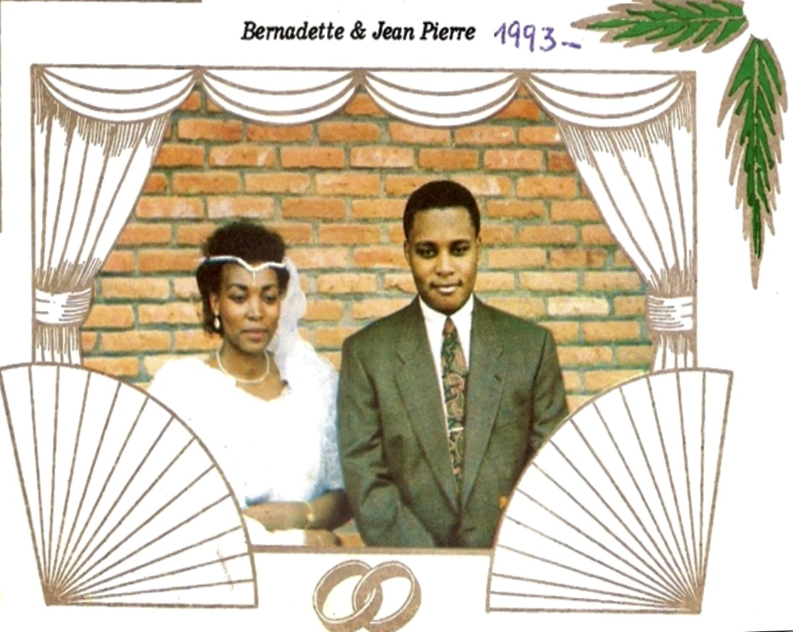
A card celebrating the marriage of Bernadette Uwamariya, Kabuga’s daughter, to President Habyarimana’s eldest son, Jean-Pierre Habyarimana, in 1993.
Kabuga became a high-profile backer of the MRND’s youth militia, the Interahamwe. What started out innocently enough as a football-based Kigali youth group under the MRND banner, was soon taken over by extremists in the party and used for far more sinister actions - violent, racist and politically destructive attacks targeting MRND’s political opponents – as well as Tutsi who were accused of assisting the RPF. He gave materials to a tailoring workshop in Remera, Kigali, owned by a business woman named Charlotte Nyiransengimana, where the interahamwe’s uniforms were made.
According to a report in the journal Nyabarongo (13th March 1993), in autumn 1992 there had been a meeting at President Habyarimana’s residence in Kanombe, Kigali, in which Akazu personalities gathered to discuss the future. Kabuga and his wife Josephine joined regime hardliners including Colonels Laurent Serubuga, Anatole Nsengiyumva and Theoneste Bagosora, the president’s brother Seraphin Bararengana, Protais Zigiranyirazo (Z), Seraphin Rwabukumba and Joseph Nzirorera. The attendees were treated to champagne and impungure canapes (beans mixed with corn). Speeches were made that called for urgent action to help retain their wealth and power gathered during 20 years of corruption and misrule.
Besides providing material and political support for the interahamwe, Kabuga’s financial clout played a vital role in establishing what became known as Hutu hate radio - Radio-Télévision Libre des Mille Collines, Société Anonyme (RTLM, SA). In Autumn 1992, Ferdinand Nahimana had approached Kabuga with an idea for a private radio station. The fact he saw Kabuga as a natural ally of the project was no coincidence – here was a man who could not just inject significant funds to get the project off the ground, but was closely linked to the Habyarimana/Akazu, had extensive contacts within the regime and, most importantly, was seen as being highly sympathetic to the ‘Hutu power’ ideology, as it would later become. On 8 April 1993 at Village Urugwiro – the office of the President – RTLM’s founding statutes were signed and published. Kabuga was named as President of RTLM and Chairman of its initiative/steering committee. On 17 June Kabuga wrote to the minister of information to inform him of the creation of RTLM.

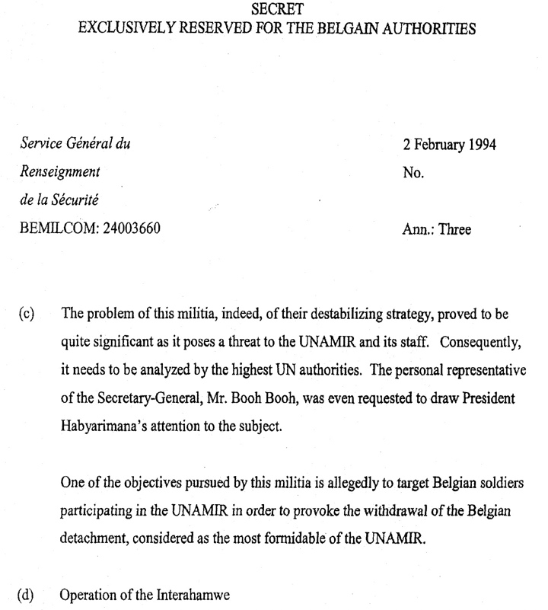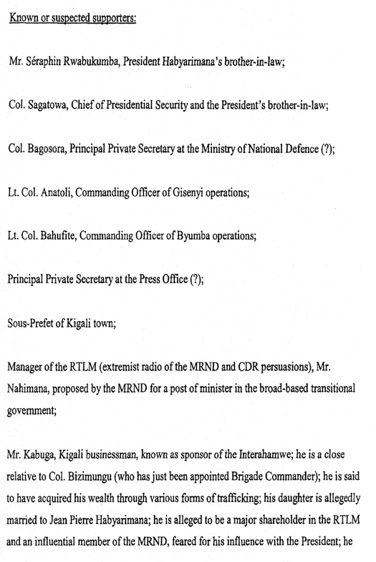
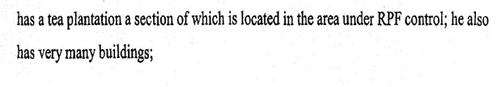
Belgian military intelligence report, 2 February 1994, two months before the start of the genocide, noting the threat of the interahamwe and its ‘known’ supporters – including Kabuga described as ‘a known sponsor of the interahamwe’
Kabuga used his influence in pushing MRND allies to sign up and buy shares in the private radio station. A meeting at Kigali’s Amahoro Hotel raised several million Rwandan francs with attendees treated to speeches by Kabuga and other members of the ‘initiative committee’. Leading shareholders in RTLM included Habyarimana, who invested one million Rwandan francs in the new company, Kabuga (500,000 RWF), Joseph Nzirorera (500,000 RWF), Seraphin Rwabukumba, (500,000 RWF) and Col. Bagosora (250,000 RWF). As president of the station, Kabuga twice led RTLM delegations to meet the Minister of Information Faustin Rucogoza after the radio station was accused of spreading malicious lies on air and inciting ethnic violence – this in a country that by late 1993 was already teetering on the edge of meltdown with daily outrages on the streets. Just weeks before the genocide, on 10 February, in the second such meeting, Kabuga denounced any attempt by Rucogoza to curtail RTLM’s ‘freedom of speech’ that was marked by a daily diet of anti-Tutsi, anti-opposition rhetoric bordering on direct calls to violence. In a direct confrontation with the minister, Kabuga intimated that RTLM would ‘continue to give time to anyone who would come to testify about Tutsi tricks and their Hutu accomplices.’
Two months later on the 7th April when the genocide was unleased, Rucogoza, his wife and two young children were among the first to be targeted by the killers; they were abducted, shot and hacked to death.

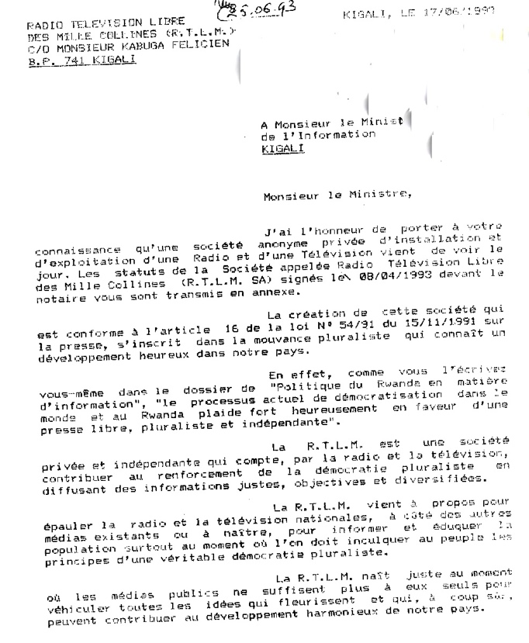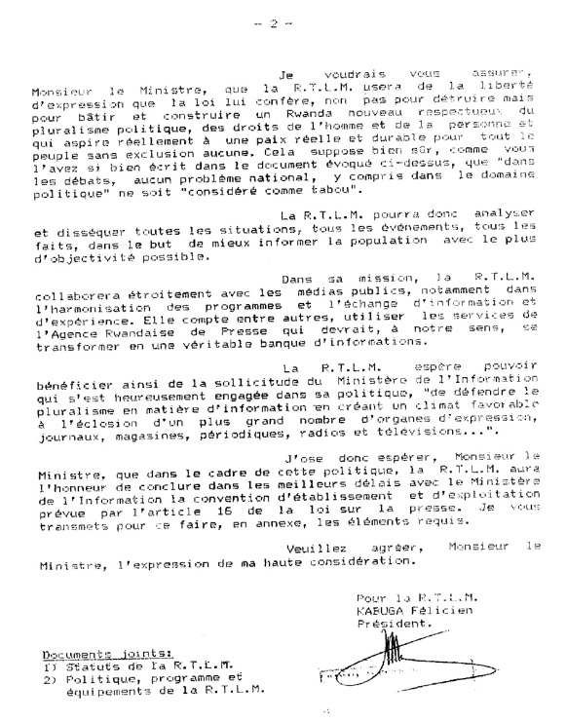
Kabuga signs a letter to the Minister of Information on behalf of RTLM, informing him of the establishment up of the private radio station, 17 June 1993.
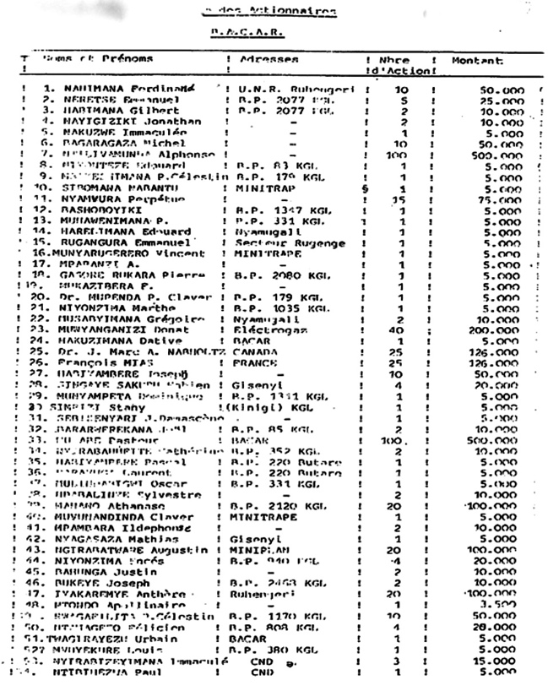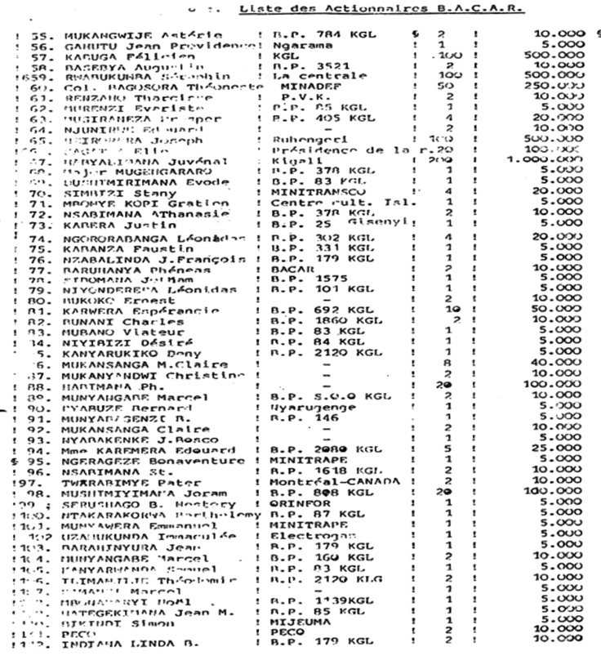
A list of RTLM shareholders, as of 1 September 1993, produced by its treasurer. Note: Kabuga (no. 57 – 100 shares costing 500,000 Rwandan Francs), Habyarimana (no. 67), Rwabukumba (no. 59).
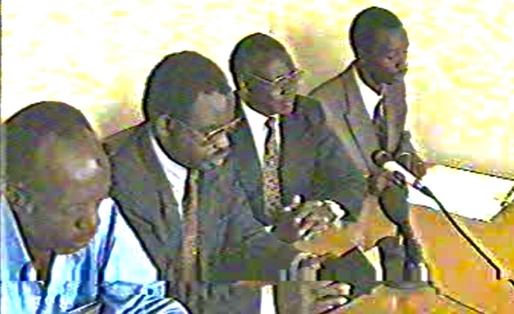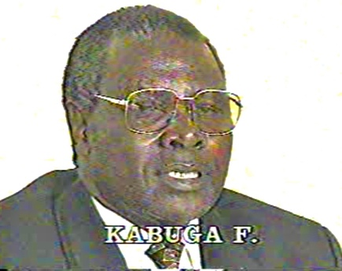
Stills from the televised, ill-tempered meeting on 10 February 1994 between Kabuga/RTLM board of initiative and Information minister Faustin Rucogoza. (From left: Phocas Habimana, Jean-Bosco Barayagwiza, Kabuga and Ferdinand Nahimana).
Kabuga’s property portfolio continued to grow in the 1990s. Besides the Byumba flour mill, he acquired an extensive real estate complex in the Muhima suburb of Kigali, which housed several public institutions including some ministries, the Gikondo warehouses (later converted into a prison), a palatial residence in Remera, another large home with a far-reaching compound in Kimironko and a tea plantation covering more than 300 hectares. At his Muhima and Kimironko buildings in Kigali, weapons were stored and training given to groups of Interahamwe, who used the buildings and compounds as local headquarters. Both places would play an important role in the genocide.
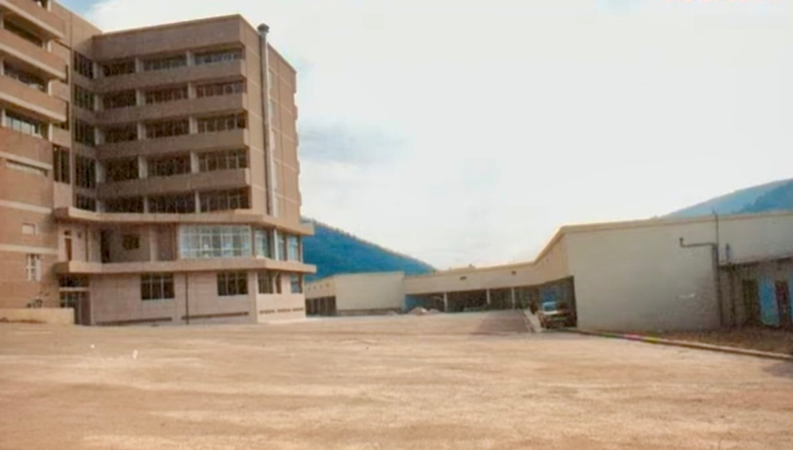
Kabuga’s Muhima property in Kigali – used for Interahamwe training and later genocide.
Source: UNMICT
Kabuga also had an eye on his international business at a time of financial meltdown in Rwanda as the country descended into social, political and economic ruin during 1993. He was aided by having his son-in-law, Fabien Singaye (married to his daughter Pauline Musanabera), working at the Rwandan embassy in Bern which was used not just as an intelligence facility in the heart of Europe but as an important economic resource for the businessman.
Genocide
On 6 April 1994, Habyarimana’s plane was shot down as it came into land in Kigali, killing the president, his security chief Elie Sagatwa and the head of the military Deogratias Nsabimana. The genocide that had been planned for and organised was set in motion in all its horror and ferocity. Roadblocks were set up, opposition politicians swiftly murdered and a new Hutu extremist interim regime selected and installed by Colonel Theoneste Bagosora in what was, in effect, a coup d’etat. The objective was to unite the disparate Hutu parties against one ‘enemy’ – the Tutsi – while taking the opportunity of the genocide and rekindled civil war against the RPF for the extremists to kill those they saw as ‘moderate’ Hutu opponents. Witnesses noted Kabuga arrived at his Muhima estate in Kigali on 7th April already dressed in the interahamwe ‘kitenge’ uniform. Groups of interahamwe also arrived in trucks owned by the businessman. Tutsi who had also been brought to the site were later taken away and murdered after Kabuga left. Kabuga’s large residence, in the exclusive Kimironko area of the city, was used by interahamwe as a base for operations during the genocide. Here, a group known as ‘Kabuga’s interahamwe’ that numbered around fifty, spent the following three months until the fall of the city killing any Tutsi they could find. In the weeks and months before the genocide began spent inside Kabuga’s Kimironko compound, they had been clothed, armed and trained/indoctrinated to kill Tutsi. During 1993, neighbours who entered the property had noted interahamwe had built up an extensive stockpile of weapons – including rifles, grenades, clubs and machetes. As with those militia at Muhima, most of these killers came from Kabuga’s home region in Byumba. Kabuga was also known to support other local interahamwe groups, who manned a roadblock only few hundred metres away and known as ‘Groupement.’ Indeed, the roadblock here with Kabuga’s interahamwe was set up even before the genocide was set in motion on 7 April. It was known to be the most destructive and dangerous roadblock in the area. Kabuga-supported Interahamwe, from his home commune in Byumba, also took part in mass slaughter at a nearby church and school where local Tutsi had sought refuge.
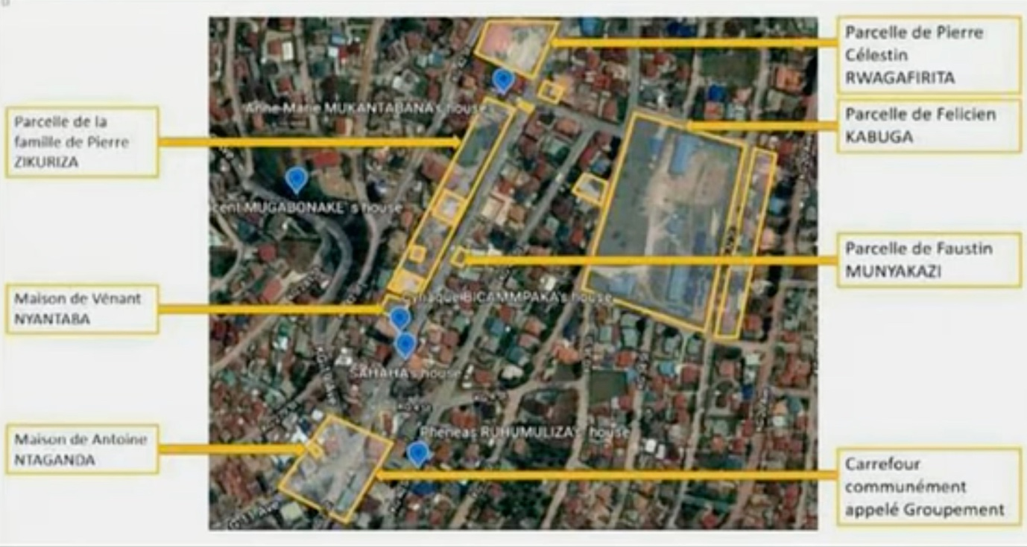
UN diagram map showing Kabuga’s extensive house and compound complex in Kimironko, Kigali, which his interahamwe group used to train and store weapons; bottom left is the infamous ‘Groupement’ roadblock manned by Kabuga’s militia and that of interahamwe chief and member of its national committee, Phénéas Ruhumuliza who lived just metres away. Courtesy of UNMICT
It became clear within days that while the genocide was hugely successful – tens of thousands of Tutsi were murdered in the first days alone – the renewed civil war against the RPF was going badly for the new genocidal interim regime. Its politicians had fled from Kigali to the safer haven of the central Rwandan town of Gitarama within days of the start of the genocide. There was a desperate need to arm and train new recruits for ‘civil defence’ forces – a term used for Hutu militia such as the interahamwe.
On 25 April Kabuga organised a meeting in the north west town of Gisenyi to create the ‘Fonds de Défense National’ – National Defence Fund. Its purpose was to reprovision the militias for the genocide. Monies raised were deposited in the Banque Commerciale Populaire de Rwanda. In a letter dated 25 April to Prime Minister Kambanda, Kabuga noted this new fund was to ‘fight the enemy and its accomplices,’ and to ‘make traditional weapons (bows and arrows, spears, swords…) available’ in large quantities for Rwandan youths to use. The Gisenyi event raised three million Rwandan Francs, and Kabuga urged Kambanda to make this example one that should be followed nationally. It was obvious that such ‘traditional weapons’ were not going to be used in the civil war against the RPF – the machetes, hoes and axes that were to be bought and given to the interahamwe militia had only one target use – the genocide of Tutsi civilians. As the later ICTR judgment against two political leaders of Kambanda’s regime found: ‘Kabuga made it clear in his letter to the Interim Government that he intended to use the fund to purchase traditional weapons for the military, militiamen, and civilians. In these circumstances, the only reasonable conclusion is that Kabuga and the assailants who physically perpetrated the killings possessed the intent to destroy, in whole or in a substantial part, the Tutsi group’. [ICTR judgment, The Prosecutor v. Édouard Karemera and Matthieu Ngirumpatse, Case No. ICTR-98-44-T, 2 February 2012, para. 1646].
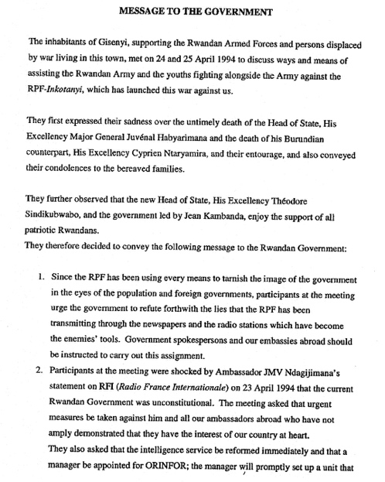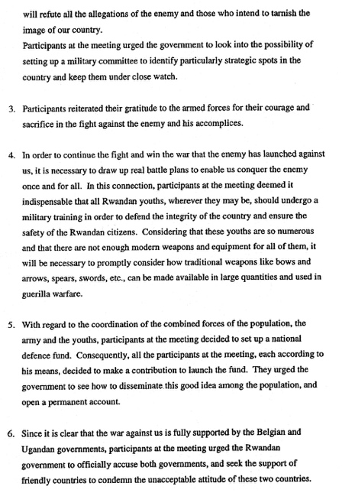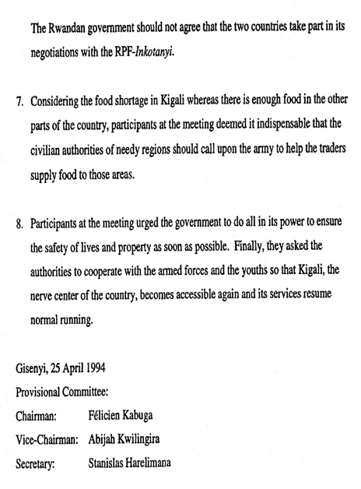
Kabuga appeals to the interim regime for his Gisenyi Civil Defence Fund to be rolled out on a national level and for the mass training and arming of youth with ‘traditional weapons’. (English translation from the French). Source: UNICTR
From April – June, Kabuga took part in fundraising meetings, including at Gisenyi’s Meridien hotel – where he and Joseph Nzirorera had rooms - and at the Umuganda stadium. The meetings brought together businessmen, politicians and wealthy individuals. It was, Kabuga told them, in all their interests to give generously to pay for weapons and an expanded Interahamwe. Should Kigali fall to the RPF, they would all lose substantial property and bank assets. The way to stop a ‘Tutsi’ takeover was to fight not just the enemy from abroad (the RPF was characterised as a ‘Ugandan’ army) but the ‘enemy’ in their midst – local civilian Tutsi. The Tutsi needed to be eliminated ‘at their roots’.
In early June, a meeting at the Meridien Hotel took place to select a committee to progress the Civil Defence fund. Kabuga was elected as the committee’s president. Also present were Joseph Nzirorera, wearing his interahamwe uniform, MRND chief Mathieu Ngirumpatse, the minister of planning Augustin Ngirabatware and Colonel Anatole Nsengiyumva, the head of the military in the town and the lead player in organising the genocide in the locality.
The former prefect of Gisenyi told investigators:
‘When I arrived at the Meridien hotel, I saw Kabuga in the hallway leading to the meeting hall. We had a private conversation that developed into a dispute in which I asked him if he was not yet tired from all this killing which had never happened in Rwanda before. And I told him all this would not lead to any good result for the country. He replied telling me that it had happened before, accusing me of being illiterate of the history of my country. He added that all Tutsis must be killed; he said that if we do not kill them, they will kill us.’
The Prefect protested was in vain. He left the meeting after Colonel Nsengiyumva told him he was just a civilian and these matters had nothing to do with him; his views were unwanted and unneeded.
In its investigation into one of the five leaders of the interahamwe in Gisenyi, the businessman Omar Serushago, the ICTR found that Kabuga was complicit in helping to draw up lists of names that were then handed to the interahamwe for them to eliminate: ‘Between May and June 1994, Anatole Nsengiyumva, Felicien Kabuga, Joseph Nzirorera, secretary general of the MRND, and Juvénal Uwilingiyimana, Director of the office Rwandais du Tourisme et des Parcs Nationaux, held a meeting in Gisenyi. During the meeting, Joseph Nzirorera and Juvenal Uwilingiyimana took note of the names of the Tutsi and moderate Hutu who had come from other prefectures. They drew up a list of people to eliminate which they handed over to the militiamen. [ICTR, Prosecutor against Omar Serushago, case number ICTR-98-39-I, 14 December 1998, Para 5.17].
While meetings to raise funds were underway, so was action to turn the money into weapons that could be used on the ground – despite a UN arms embargo being in place. Around the start of June, a group of interahamwe from Gisenyi were ordered to bring back an arms shipment that had been delivered to Goma airport – just across the border in Zaire. A witness explained to ICTR investigators:
‘Three trucks belonging to Kabuga [were] waiting at the airport. We started loading the boxes
from the plane to the trucks and the buses. We were around 80 men and we worked until 3 o'clock
in the morning. I estimate the number of boxes loaded into the trucks and the buses at around 400
boxes, some of the boxes were very heavy and needed 5 men to carry them while other boxes did not
need more than two men. I knew the trucks belonged to Kabuga because his name was written on
the driver’s door of each truck. When we finished loading the weapons into the trucks and the
buses we went back to Gisenyi. The buses stopped at the Meridian Hotel and the Prefecture
office while the trucks were instructed to continue to Gisenyi Military camp. My bus was stopped at
the Meridian Hotel and we waited there until the morning. At around 0800 hrs. Kabuga came to where the buses were and checked some of the boxes. Each of the boxes had a label with the following written on it: ‘import Filicien (sic) Kabuga via Mombassa.’ Following Kabuga’s arrival we started distributing the weapons. Some of the boxes had 10 AK47 rifles while other boxes were full of ammunition only. The weapons were given to the interahamwe and civil defence.’
On 17 June, RTLM issued a national call for more funding for the militia, naming Kabuga as an example of a generous donor, as well as other Gisenyi businessmen; The radio dj noted such personal, generous effort to ‘save our country’ … after all ‘your money would be of no use to you if your country is taken by foreigners’ (i.e. Tutsi). Business people needed to learn from Kabuga and give funds to support the army and radio stations, and even to pay for ‘white’ mercenaries.
As June turned to July, and the French intervention force Operation Turquoise failed to be the saviour of the extremists as it had been to Habyarimana’s regime in the early 1990s, regime politicians, business people, military and indeed RTLM radio all moved north to Gisenyi for safety. However, within weeks, once the RPF took Kigali and moved to take the north west, the genocidaire fled, along with hundreds of thousands of mostly Hutu refugees, into neighbouring states – notably refugee camps just inside the Rwanda-Zaire border. For the genocidal regime leaders and supporters, the immediate need was sanctuary for themselves, their families and the cash reserves they had built up during the heyday of Akazu’s power. Despite his ‘unwavering’ support for the regime in its on-going genocide and civil war, Kabuga had used the summer to ensure an effective exit strategy should it be necessary. On 6 June, with the killing in full flow, the businessman applied for visas for himself, his wife and seven adult children at the Swiss embassy in Kinshasha, in neighbouring Zaire (now DRC). Three days later these were issued. It was alleged Alexandre Hunziker, head of the Swiss immigration office and a close personal friend of Kabuga’s son-in-law Fabien Singaye who worked at the Rwandan embassy in Bern, had personally issued the visa and did not pass on an entry ban to border police. On 22 July Kabuga arrived in Switzerland with his family.Two weeks later, a lawsuit was issued in Paris that accused Kabuga of genocide. He reacted by applying for asylum in Switzerland.
Only at this point, did Swiss justice and foreign ministries, now alerted to his presence, order Kabuga and his family as persona non grata to return to Kinshasa – even being prepared to pay his air fare of $23,000 in order to get swiftly rid themselves of this most unwanted individual. On 18 August Kabuga arrived back Kinshasa – along with his funds which he had been also allowed to leave with. Remarkably, despite knowledge of his role with RTLM and the militias, no attempt was made to arrest/question him by the Swiss authorities. It was the first of many missed opportunities to bring him to justice. [See: ‘How Switzerland let an alleged mastermind of the genocide in Rwanda slip away’, Geraldine Wong Sak Hoi, Swissinfo.ch,14 May 2004].
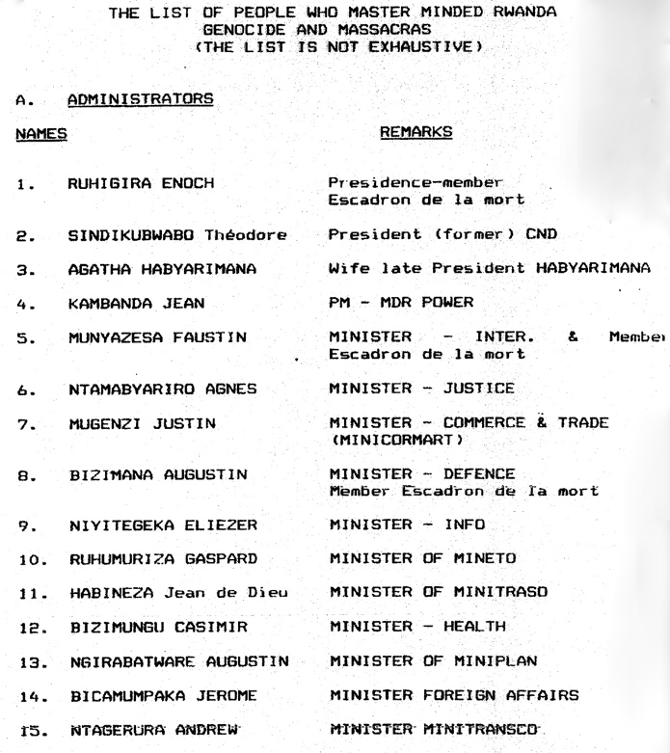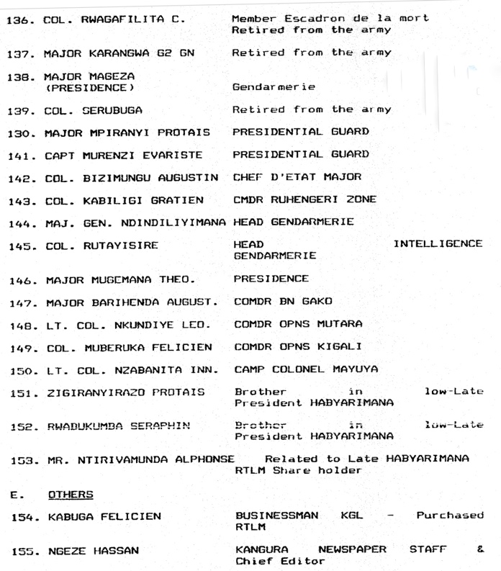
An early ‘non exhaustive’ list of 220 individuals prepared by new Rwandan government in c.1995 responsible for the genocide and ordered by the part they played. Kabuga is listed under ‘other’ and just below Agathe Kanziga’s brothers Seraphin Rwabukumba and Protais Zigiranyirazo (‘Z’). N.B. No. 137 Major Karangwa is currently facing trial in the Netherlands for genocide.
Back in Kinshasa in Autumn 1994, Kabuga moved to the luxurious initial safety of the Nairobi suburbs where Akazu personalities set up in their post-genocide retirement villas and houses, funded with their Rwandan ‘profits’. Taking up residence in the exclusive Hurlingham district where he owned property, Kabuga was able to continue his African business operations while taking part in the fundraising activities aimed at enabling the Rwandan army (FAR) and militias, now camped inside Zaire, to mount an offensive to retake Kigali. For the next two years Kabuga, his son-in-law Augustin Ngirabatware, Agathe Kanziga, Z, army chiefs such as Augustin Bizimungu and Laurent Serubuga, former prefects like Tharcisse Renzaho and Charles Nzabagerageza, and extremist media such as the Kangura journal of Hassan Ngese all benefitted from Kenya’s - and its president Daniel Arap Moi’s - warm welcome.
Moi, a longtime friend of Agathe and her dead husband, is said to have been further sweetened in his willingness to support the genocidaire in their justice-free retirement by a gift of 10 million Kenyan shillings ($171,000) from Kabuga. One year on from the genocide, as the excavation of mass burial pits and massacre sites continued throughout Rwanda, Agathe’s son Leon celebrated his lavish wedding to Kabuga’s daughter Francoise on 17 August 1995. The occasion, with 350 invited guests, cost around half a million dollars – paid for by the Kenyan MP and one-time presidential hopeful Kenneth Matiba.
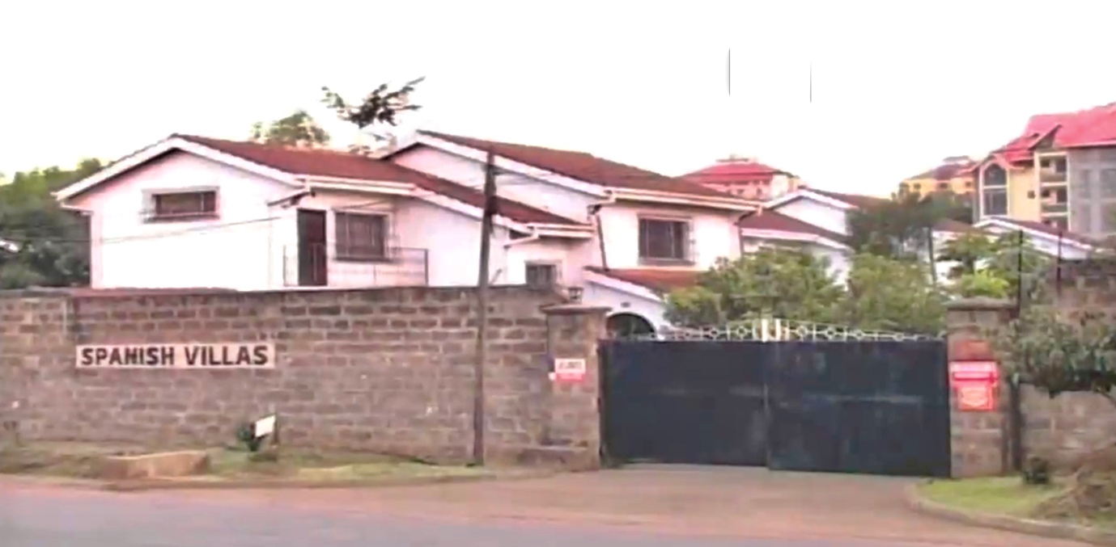
Kabuga’s Spanish Villas, his Hurlingham home in Nairobi in late 1994 and part of his extensive property empire. His wife continued to earn rent from the properties even with her husband a wanted man.
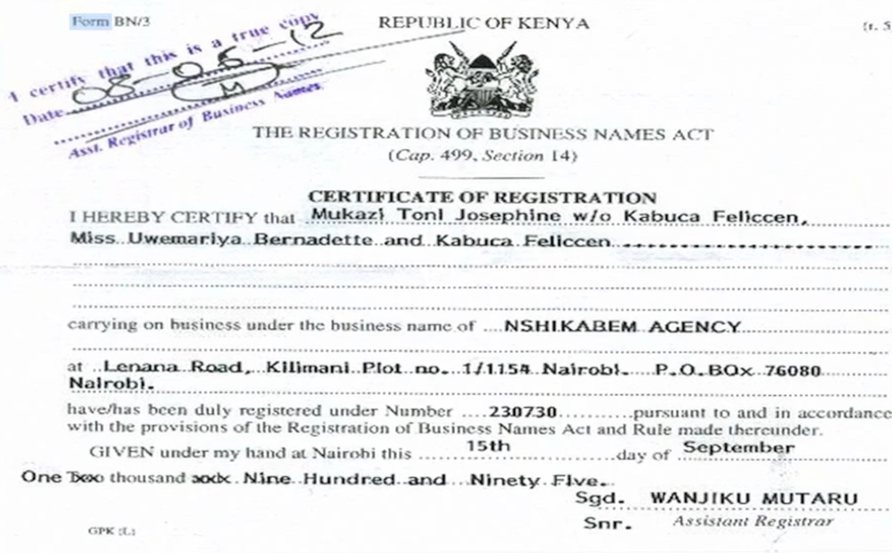
15 September 1995 – One year on from the genocide, Kabuga continued to build his business empire with impunity – here registering a new import-export company in Nairobi – the ‘Nshikabem Agency’ – registering it under the name of his daughter Bernadette and wife Josephine, and his own vaguely disguised alias of ‘Feliccen Kabuca’. It was registered as being run from his Lanana Road address.
Two years after the genocide the political and judicial indifference of the international community was already noticeable. In November 1994 the UN had voted through the establishment of a special tribunal to judge those held most responsible for the genocide that the world had watched and allowed to happen. Yet these same genocidaire whose names were widely known and publicly named – such as Kabuga - continued to enjoy freedom and impunity. Moreover, they were allowed to travel without hindrance, buying millions of dollars of new weaponry for their former regime military and militia who were camped on the Rwandan border, readying for an invasion. That this invasion in 1995/6 never happened - and a relaunch the genocide - was due not to international sanctions or a proactive response from the UN but the sheer corruption and incompetence of the FAR leadership. As the new Rwandan government representative plaintively told the UN Security Council two years after the start of the genocide:
‘Those responsible for the genocide in Rwanda and their militias enjoy refugee status, when they are actually armed and leading an armed group. The Government of Rwanda would like to encourage national reconciliation. But what meaning can reconciliation have if it takes place between those who survived the genocide and its perpetrators, when the latter are in the process of rearming themselves to carry out other massacres.’

Kabuga was named as one of the Akazu constantly travelling to/from Kenya in order to finalise arms deals and gain political support for the invasion, with no attempt made to arrest him. In 1996 the Rwandan government forestalled any invasion by launching its own counter invasion of Zaire. Meanwhile, the first arrests by the UN tribunal finally came after pressure on Moi and Zaire’s president Mobutu to cease protecting the ‘refugees.’ Unlike many who were arrested, Kabuga’s very deep pockets and notable corrupt links with high-ranking members of Kenya’s political, security and police apparatus were to keep him safe from justice over the coming years.
On 18 July 1997 UN and Kenyan police had moved to arrest Kabuga and other wanted Rwandan genocidaire in Nairobi during ‘Operation Naki’. Though successful with other targets, including former regime prime minister Jean Kambanda, Kabuga proved elusive. He had been living at a house belonging to the nephew of President Arap Moi, a certain Hosea Kiplagat – and neighbouring one belonging to Moi’s son Gideon. Kabuga also stayed at homes he owned in the Karen district, in Nakuru and in Eldoret. When the tracking team came to arrest Kabuga in the Eldoret home, all they found was a note from a Kenyan police officer tipping him off. One years later in autumn 1998, Kabuga was spotted in south east Asia, where arms dealing for the former genocidal regime was on the agenda. In 2000, Kabuga moved through Belgium where wife Josephine and some of his adult children had relocated.
According to Farah Stockman, a Boston Globe journalist who investigated the Kabuga file at this time, the businessman was worth around $20 million in assets and cash (around $38 million in 2026). While efforts were made to freeze Kabuga’s assets - especially in France, Belgium and Switzerland - these were not implemented in many countries such as Kenya. Indeed, witnesses reported seeing him being ferried to the airport in a car belonging to the head of the Kenyan military.
In 2002, the exasperated US ambassador-at-large for war crimes, Pierre-Richard Prosper, went public in claiming Kabuga had been using ‘government infrastructure to maintain his fugitive status in Kenya.’ As Agathe Kanziga, Seraphin Rwabukumba and even Z chose to move to Europe to escape justice, Kabuga, with his business empire based in East Africa, felt safe enough to stay, using his wealth, family members and trusted local associates to ensure impunity within Kenyan government and security structures known for their easily corrupted status.
On 13 January 2003 a 27-year-old associate of Kabuga, Kenyan journalist William Munuhe, was found murdered in Nairobi. Munuhe, it seemed, had been tempted by the $5 million bounty the USA had put up for information and had planned to tip off the tracking team about Kabuga’s whereabouts. Instead, Munuhe’s tortured body was found at his blood-soaked home with strong suspicions that the arrest had failed due to another Kenyan informer. The official police report put Munuhe’s death down to ‘suicide’.
Another missed opportunity to arrest Kabuga came in Germany, where he had gone under one of 20 aliases, and several passports he had acquired, to receive private medical treatment for a benign throat tumour. On 7 September 2007 police arrived at the Frankfurt house of his son-in-law, Augustin Ngirabatware. They promptly used an arrest warrant to take him into custody, but failed to search his house, where it later transpired Kabuga was staying at the time. In 2008, African Press International published an alleged interview with Kabuga it said had been recorded in Oslo, Norway, where the genocidaire was staying at the time. Whether this interview ever took place is a matter of dispute and by 2009 Kabuga was back in Kenya and being given round the clock protection by a unit associated with very senior Kenyan government authorities. One of this ‘personal protection squad’, Michael Seronei, who took secret pictures of Kabuga when he was briefly hospitalised, was abducted and murdered in early 2009. Another member of the ‘protection team’ testified this murder was done on Kabuga’s personal instructions because Seronei threatened his security. The Kenyan government, under pressure for its rumoured links to Kabuga, issued statements saying that the fugitive had left the country. However, this raised more questions – where and when had Kabuga been staying in Kenya? when did he leave, and to where? And if the Kenyan authorities knew he had left the country, why did they allow this and not arrest him? All such questions went unanswered.
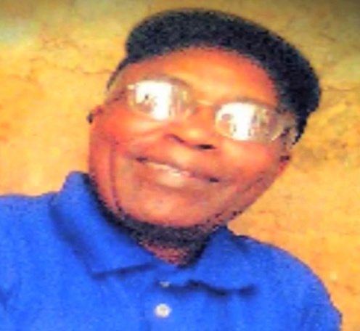
A picture purported to be of Kabuga, secretly taken around 2008 in Nairobi by a member of his protection squad. His shirt bears a Kenyan government coat of arms.
In 2011 the ICTR, which was due to close its doors within three years, moved to ‘protect the evidence by a special deposition for a future trial.’ In effect, having witnesses come forward to give evidence that could be used later, if Kabuga was ever arrested and stood trial. It was apparent to all that as witnesses aged and in some cases were no longer able to give their important evidence due to illness or death, the case against Kabuga was weakened. Interestingly, Kabuga’s family, while sheltering the killer from arrest and dismissing this ICTR action, audaciously asked for the prosecution evidence to be made available to them. The answer was clear – if Kabuga was innocent, let him stand trial and clear himself.
In February 2017, Kabuga’s wife Josephine Mukazitoni died in Waterloo, Brussels. The UN and local police ‘swarmed’ the extensive funeral commemorations in the hope, if not expectation, that Kabuga would try to attend but with no luck. In fact, as it transpired just three years later, Kabuga was at the time living contentedly in an apartment only 150 miles away in northern Paris. The wanted genocidaire, now ailing from diabetes as well as other health conditions, had made France his home from the early 2010’s - using the alias Antoine Tounga from Congo. He was assisted by a number of family members: eight lived in southern Paris including Bernadette Uwamariya, Innocent Twagirumukiza, Gilbert Habumukiza, Jean de Dieu Sibomana, Félicité Mukademali, Félicité Mukademali and Angélique Uwihirwe; Winnie (Winifred) Musabayezu, Claudine Marie Twagirihirwe (Cherry) and Donatien Nsmyumuremye were in Brussels, and the divorced Séraphine Uwimana with her two children in Brockley, London. Added to which were the Habyarimana clan – with Agathe Kanziga living in the affluent Courcouronnes suburb surrounded by many of her own children.
Kabuga’s family moved to protect him with an ever increasing ‘circle of trust’ of those allowed to know where he lived. However, what could not be covered up entirely was the need to communicate with each other about his care arrangements. It left an opportunity for a revigorated UN tracking team to put in the painstaking work analysing telephone and bank accounts to find the break through that would finally lead to the killer’s arrest. In summer 2019 Bernadette made a payment of $10,000 to Beaujon Hospital, located in Clichy - also in the Hauts-de-Seine department near Asnières. It was to cover the cost for colon surgery for an elderly Congolese man named Antoine Tounga.
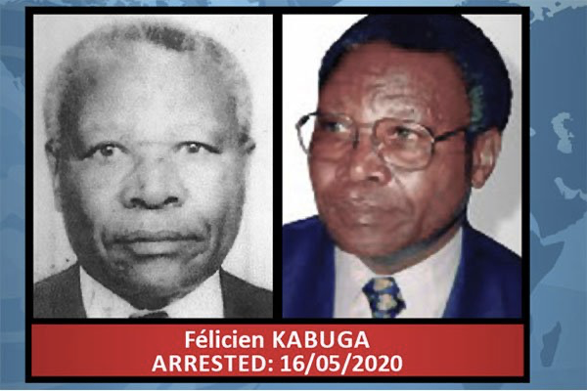
After 25 years on the run, the UN could finally change its ‘wanted’ poster to
show Kabuga had been arrested.
At the start of the COVID pandemic in early 2020, the UN genocide tracking team made some key breakthroughs on ‘Operation 955’ – the codename for the capture of Kabuga. Working on intelligence and financial details, they suspected Kabuga was likely hiding in either the UK, Belgium or France where his children were located. They then zeroed this down to Paris after tracking the phone of those of his children who seemed, for no real reason, to be spending increasing time in the suburb of Asnières where they had no apparent reason to be if not looking after someone. Analysis of bank accounts found the payment for the treatment of ‘Antoine Tounga.’ The DNA of this elderly ‘Congolese’ national matched that taken by German police in 2007 from a man treated in Frankfurt who the police now knew to be Kabuga.
At 6.20 on Saturday morning, 16 May 2020, French police and members of the UN tracking team raided an unremarkable, one bed, third-floor apartment on Rue de Révérend Père Christian Gilbert, in a residential quarter of Asnières in the Hauts-de-Seine of Paris. There they found Kabuga’s son, Donatien Nshimyumuremyi; and lying on a bed in the next room, the wanted genocidaire. Kabuga denied he was Rwandan – insisting he was a Congolese national. However, a scar from his 2007 operation in Germany and a swift DNA test disproved his lie and he was taken into custody. The apartment had been rented out for several years under the name of Habumukiza – the name of one of Kabuga’s sons. Three other apartments belonging to his children were also raided at the same time. Kabuga was transferred to La Sante prison in Paris while extradition proceedings began. The UN Mechanism applied to France for Kabuga to handed over to them to be tried in The Hague. The COVID outbreak precluded the case going to Arusha in Tanzania, the home of the former UN Rwandan tribunal.

At Kabuga’s extradition proceedings in Paris, his children who had shielded the genocidaire from justice for so long, turned out to support him, shouting out ‘Courage papa!” when he appeared. Among them were his daughter Françoise Mukanziza, married to Léon Habyarimana and living in Paris, son Gilbert Habumukiza and Winnie Musabayezu (who married the secretary-general of interahamwe Eugène Mbarushimana who is currently under investigation by Belgian prosecutors).
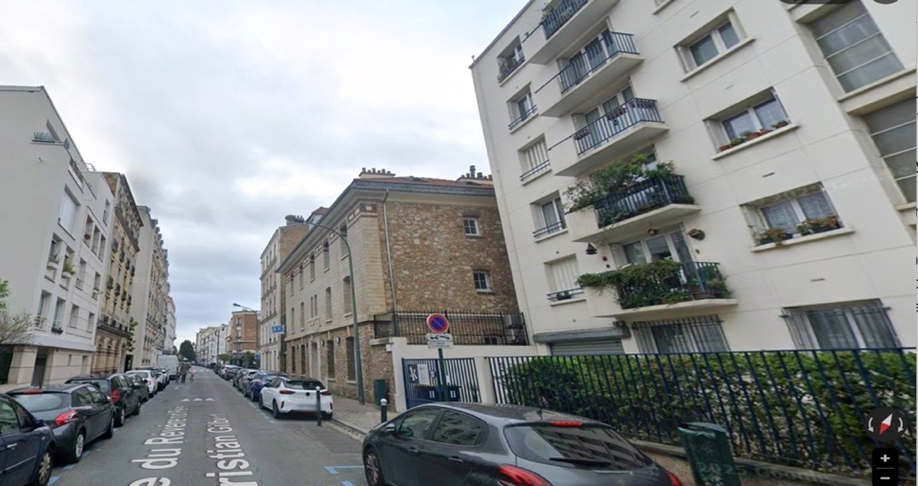
Rue de Révérend Père Christian Gilbert, Paris – Kabuga’s final refuge from justice.
In November 2020 despite the best efforts of his defence lawyers to delay the inevitable, Kabuga was cleared by French authorities to be transferred to The Hague for trial before the UN Mechanism (UNIRMCT) – the successor to the ICTR. His initial appearance was on 21 November. His lawyers again argued that proceedings should be suspended due to Kabgua’s age and infirmity, and he should be released on bail. This legal wrangle over whether Kabuga was mentally and physically able to be tried continued throughout 2021.
Finally, in autumn 2022, more than two years after his arrest, Felicien Kabuga’s trial began at The Hague, with opening addresses made on the 29 and 30 September by the Prosecution and Defence. Kabuga was charged with genocide, direct and public incitement to commit genocide, conspiracy to commit genocide, persecution on political grounds, extermination, and murder as crimes against humanity. However, this was a far from ‘normal’ trial of a wanted genocidaire. For a start, the prosecution was stymied by an agreement that a trial, already 28 years in the making, should be reduced to highly limited hours of proceedings, due to concerns about Kabuga’s age and mental capacity to follow what was going on. It also became clear the logistics of having the trial in The Hague meant many witnesses in Rwanda would need to travel 1000 kilometres to Arusha where there were video conference resources available at the Mechanism building. This involved visas and complex travel arrangements. Then there was the internecine struggle within the Kabuga family/legal camp over who should represent him. His initial defence lawyer, Emmanuel Altit, was rejected by Kabuga’s family who wanted the controversial American lawyer Peter Robinson appointed. Robinson was under investigation for corruption in regard to his actions in a previous case when he represented Kabuga’s son-in-law, Augustin Ngirabatware. Despite Altit offering to stand down as Kabuga’s lawyer, he was ordered to remain, given any change would lead to yet more delay in the case.
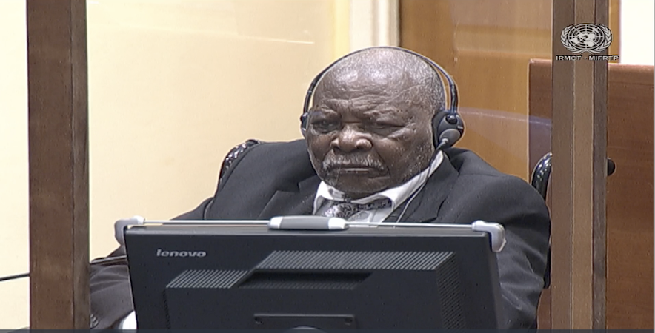
15 November 2022: Kabuga listens intently to the prosecution case, The Hague. Source: UNIRMCT
Once begun, events in court were exceptionally difficult to follow. Kabuga attended in person on some occasions, on others he remained in the UN detention facilities and was present by video link. Prosecution witnesses, more often than not, were heard in camera – only three of their 24 witnesses were in public which made a nonsense of the importance of transparent proceedings that survivors could follow. As important, the open, digital archive that the trial was meant to produce was often nullified with widescale redaction, deletion and suppression from public view of the hugely important testimony and statements. Whole days of witness testimony - much of it from former interahamwe who had worked with Kabuga - was ‘classified’ and so not streamed or recorded for public view.
[The trial transcripts of the days when the case was active can be accessed here https://rwandajustice4genocide.org.uk/felicien-kabuga-on-trial-at-the-hague-unirmct/#resources]

The start-stop nature of the case continued to an ever-slower timetable into January and February 2023. In March, three independent medical experts opined that there were serious doubts about Kabuga’s continued fitness to stand trial. According to defence lawyer Dov Jacobs, the medical experts concluded in a report dated December 2022 that Kabuga was suffering from significant deficits in the following areas: ‘short-term memory (acquisition and retention); episodic confusion, complex decision-making; attention and concentration, reasoning and judgment and executive functioning (i.e. doing tasks in the right order), expressive and receptive communication, as well as fluctuations in his mood and personality change’. The Scottish Presiding Judge Iain Bonomy ordered a stay in further proceedings while new submissions from the defence and prosecution were heard.
On 6 June, after nearly three months of legal argument, Bonomy issued a judgement finding that Kabuga was unfit to participate in his trial and was unlikely to ever regain this fitness in the future. Hence there should be an alternative ‘finding procedure’ of the facts. This was appealed by the defence and on 7 August, the Appeals Chamber instructed the Trial chamber to ‘impose an indefinite stay of proceedings,’ and dismissed the alternative for the trial chamber to continue with a basic ‘findings procedure.’ It instructed that Kabuga should be released once a state could be found that would have him. The trial of Kabuga, so long awaited, was shelved permanently.
The UN prosecutor, Serge Brammertz, who had led the successful search for Kabuga, found it difficult to contain his frustration at the appeal court decision. He noted:
‘I have carefully reviewed the Appeal Chamber’s decision in the Kabuga case. Its decision must be respected, even if the outcome is dissatisfying. This result is due first and foremost to Kabuga’s flight from justice for so many years. In full knowledge of his actions before and during the 1994 Genocide against the Tutsi in Rwanda, he refused to stand trial before an independent and impartial international tribunal to answer the charges against him. As a fugitive, he was harboured by his family and associates, beginning in Kenya and ending in France. My thoughts are with the victims and survivors of the Genocide. They have maintained their faith in the justice process over the last three decades. I know that this outcome will be distressing and disheartening to them. Having visited Rwanda recently, I heard very clearly how important it was that this trial be concluded’.
The issue now before the Mechanism was what to do with Kabuga. His Defence team had started to identify states where he could be provisionally released to - which turned out to be France, Belgium and the UK. These three states were adamant that they would not accept Kabuga onto their territory. Indeed, the only state where he was ‘welcome’ was his home country – Rwanda. His family and defence team vigorously refused to contemplate this – complaining Kabuga’s health was too bad to survive the trip, and if he was returned to Kigali, the change would lead to a further decline in his health and his family would not be able to visit him. Regular medical monitoring and occasional tribunal case conferences continued throughout 2024-5, with Kabuga all the while benefitting from expert UN medical care. Attempts by the UN to get the family to pay for the millions of dollars the case cost were blocked as effectively as justice had been in court. The fact UN taxpayers picked up the bill for Kabuga’s legal affairs despite him being one of the richest individuals ever to appear before it was symptomatic of an international justice system that seemed weighed heavily in favour of the rights of the accused and against the administration of justice.
On Saturday, 16 May 2026, the UN announced that 91 year-old Kabuga had died in the prison hospital at its detention centre in The Hague. The news was met in the main by a deafening media silence. Unlike his arrest six years earlier to the day, on 16 May 2020, which had made world headlines, Kabuga’s death was hardly reported. Newspapers in the UK almost totally ignored the story. Even in France, home of many of the remaining genocidaire, it was just a passing note for most editors. The UN immediately announced an inquiry into Kabuga’s demise as is the case with all deaths in custody. In a last statement on this final aborted MICT case, presiding Judge Bonomy noted: ‘Reflecting on the last six years, it seems to us that this case has highlighted a systemic gap in international criminal procedure that the Trial Chamber hopes the international community will continue to examine; namely, how to achieve justice for an accused and for victims of alleged crimes following a determination that an accused is permanently unfit to stand trial.’ As the accused gets older – as do witnesses – how does international justice adapt? or does it just accept, as the Mechanism did in the case of Kabuga, that nothing more can be done? Sadly, this is not a new dilemma; countless Nazi Holocaust perpetrators escaped justice because they were deemed too old or infirm by the time international/national law caught up with them. After 80 years, justice is still failing the victims and survivors of genocide and war crimes.
No doubt too that members of Kabuga’s family which sheltered their killer father from justice, will now undertake new legal battles to get their hands on his extensive ‘blood monies’ that Kabuga acquired. Of course, none of this wealth will go near Rwanda, to survivors of the genocide, to assist those mentally, physically and emotionally devastated by the horrific crimes of Kabuga’s life.

Kabuga’s nickname of ‘the financier of the genocide’ is neither appropriate or accurate. Without his wealth the 1994 genocide against the Tutsi would still have taken place. However, Kabuga chose to use his wealth, his powerful connections and his racist ideology to enable, protect and prosper Hutu hate radio RTLM; and with his local/national funding/fundraising activities and logistical/political support for the Interahamwe, he gave it highly significant assistance to carry out numerous brutal genocidal killings/rapes of women, children and men. It is impossible to quantify the actual number of Tutsi dead to lay at Kabuga’s door – or the suffering and pain to those who survived. The failure of the international community and national governments such as Kenya, France and Switzerland to arrest Kabuga over many years - or in the case of Kenya to actively protect him - brings into sharp focus the way wealth and indifference to genocide can corrupt the stated adherence to the Genocide Convention. The eventual manner of Kabuga’s arrest in Paris, the failure of justice to be done at the UN Mechanism and his death while in a state of judicial limbo with no country wanting to touch a man with so much blood on his hands is symbolic of his life. Kabuga put greed and genocide first. In life he successfully ran away from his bloody crimes. In death, he cannot escape his legacy.

Rwandajustice4genocide.org.uk May 2026

